There is no center

Grapgh connected: false

The distance from src=0 to dest=2 is 0.0

The shortest path is 0>2

Center :10

Grapgh connected :true

The distance from src=1 to dest=11 is 1.654

The sortest path is : 1->9->11

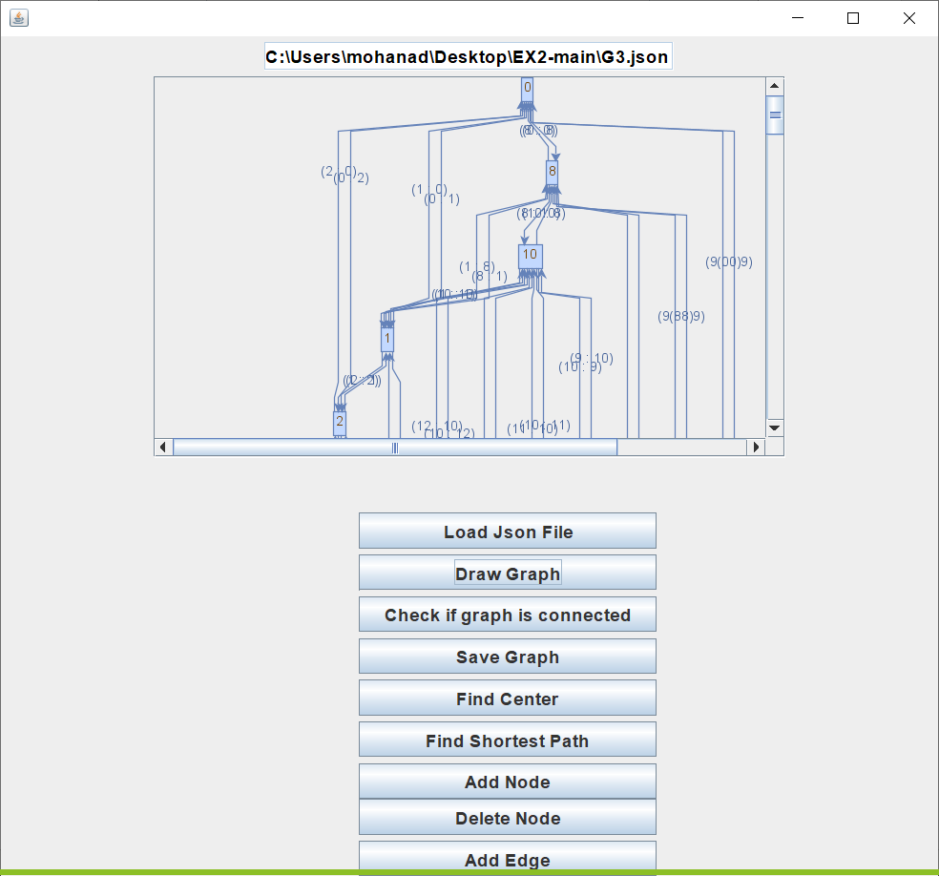

Center 8

Graph connected: true

The distance from src=2 to dest=1 is 1.5784

The shortest path is: 2->1

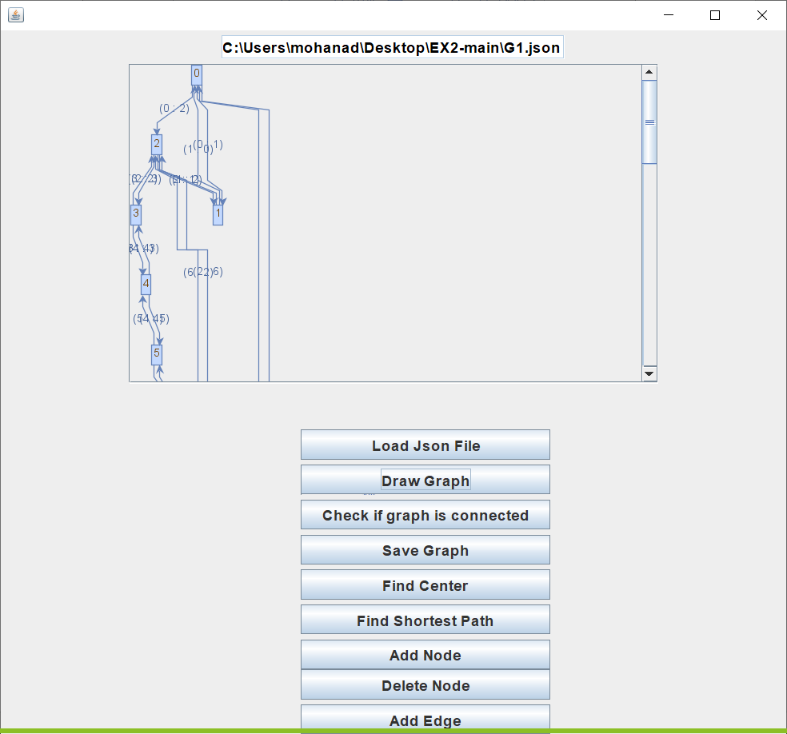

EX2:RESULTS:

Time analysis (average of shortest path, center):

a. size 1000: 10ms

b. size 10000: 80ms

c. size 100000: 670ms

d. size 1000000: 1.2 seconds

EX3:RESULTS:

Time analysis (average of shortest path, center):

save size 1000 took: 0.5882960620000001 seconds

save size 10000 took: 6.075032675 seconds

save size 100000 took: 55.629878526 seconds

save size 1000000 took: 499.512196316 seconds

Results for center ->

A0 - (7, 6.806805834715163)

A1 - (8, 9.925289024973141)

A2 - (0, 7.819910602212574)

A3 - (2, 8.182236568942237)

A4 - (6, 8.071366078651435)

A5- (40, 9.291743173960954)